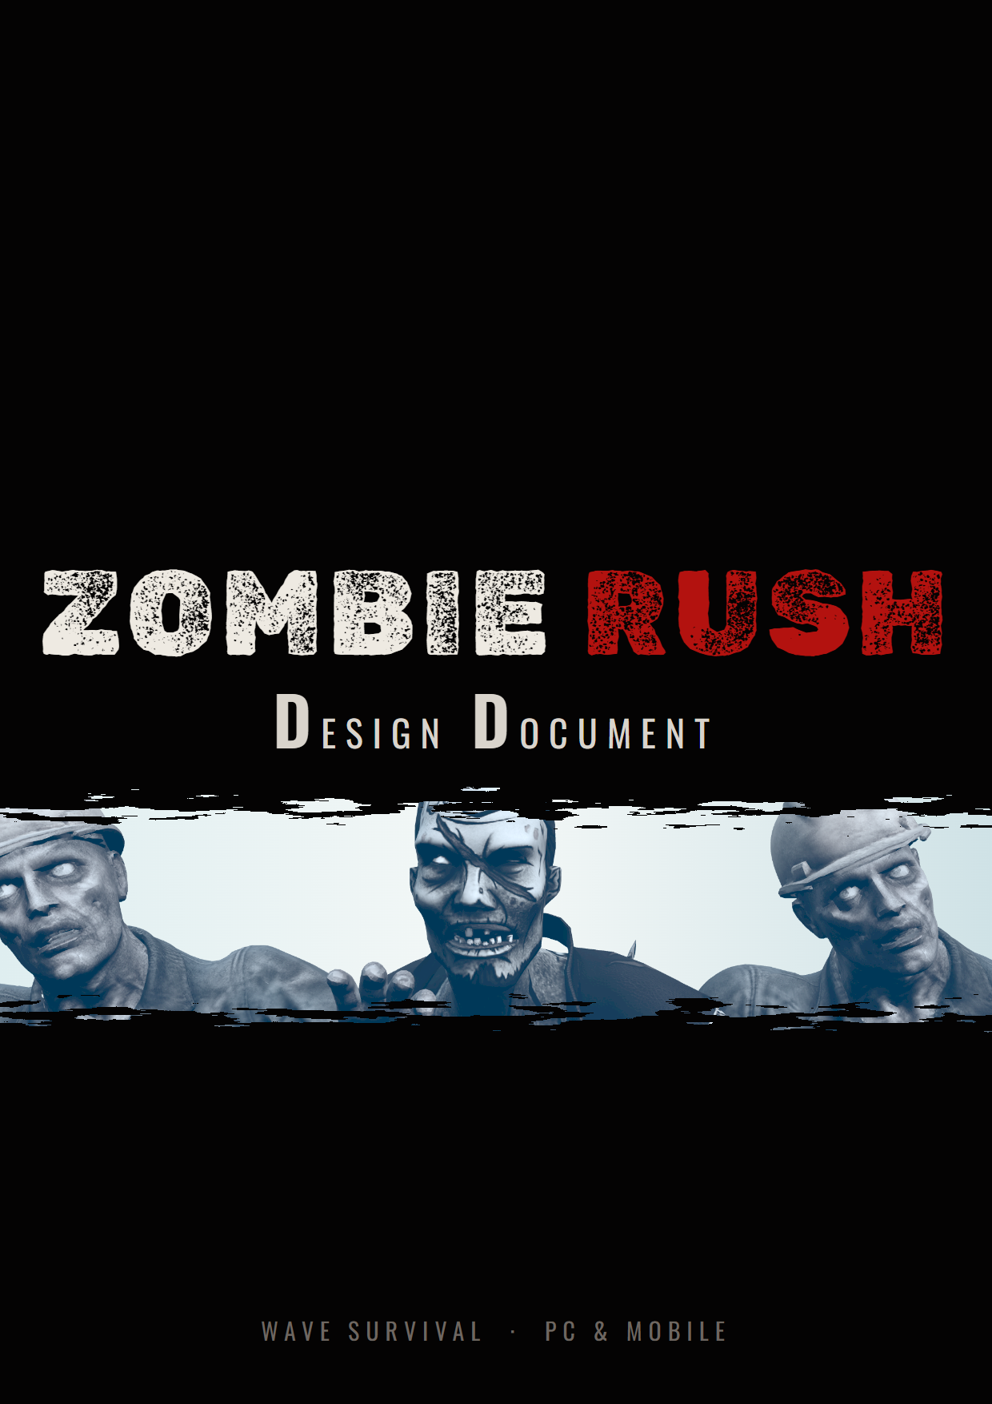

Preface
This document is the Game Design Document for Zombie Rush, a first-person wave-survival shooter for PC and Android. It has two jobs. The first is to record what has already been built in Unity: the player controller, the two weapons, the wave system, the zombies and their behaviour, the coin economy and the expanding safe zone. The second is to set out the design for the parts that are still to come, such as the menus, touch controls, audio and online co-op, so that every later piece of work has a clear target.
Every number quoted in the mechanics chapters (health values, speeds, damage, costs, timings) is taken directly from the current build, so the tables in this document can be used as a balancing reference. Where a section describes something that has not been built yet, it is marked as planned or as a proposal, and the values there should be treated as a starting point rather than a decision.
The layout of this document deliberately follows the structure of a classic console-era design document, moving from the concept, through mechanics and interface, to art, sound, story, levels and market.
Mian Sarmad
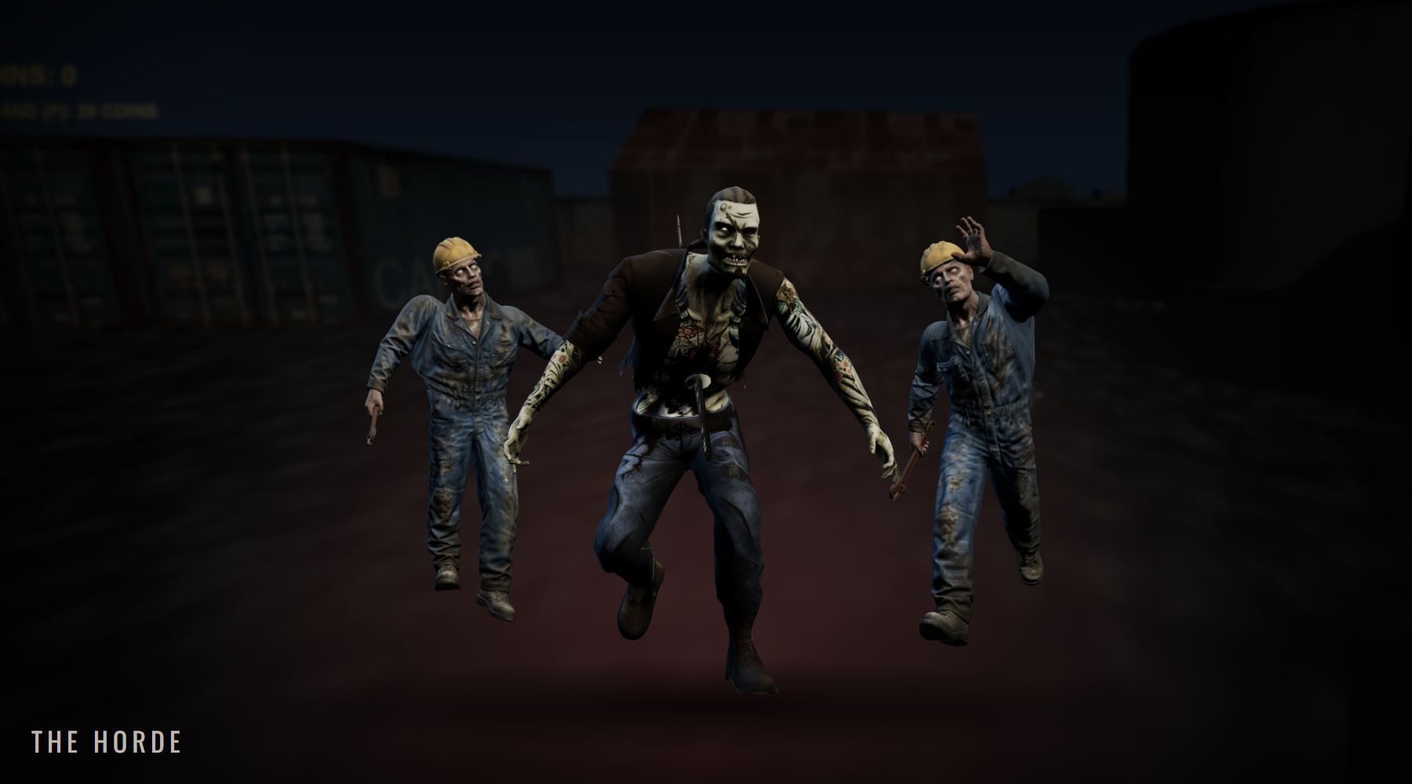
Contents
Game Concept  Introduction  Background  Description  Key Features  Genre  Platform  Development Status  Concept Art  Game Mechanics  Core Game Play  Game Flow  Characters  Zombies  Game Play Elements  Weapon Properties  Game Physics and Statistics  Artificial Intelligence  Player Controls  Multiplayer  Interface  Flowcharts  Functional Requirements  Mock Up Screens | P4  P4  P4  P4  P4  P5  P5  P6  P7  P9  P9  P9  P10  P10  P12  P13  P13  P13  P14  P14  P16  P16  P19  P21 | Art and Video  Overall Goals  2D Art  3D Art & Animation  Cinematics & VFX  Sound and Music  Overall Goals  Sound Effects & Music  Story  Story Overview  Endings & Progression  Level Overview  Location Overviews  Zone Expansion  Market Analysis  Target Market  Top Performers  Feature Comparison  References | P23  P23  P23  P23  P24  P25  P25  P25  P26  P26  P26  P28  P29  P29  P31  P31  P31  P31  P33

Game Concept

Introduction
Zombie Rush is a first-person wave-survival shooter for PC and Android mobile. The player holds a small fenced area of an abandoned industrial yard against ever-growing waves of the undead, who claw their way up out of the ground from every direction at once. Every zombie killed pays out coins, and coins are spent to push the safe zone outward and claim more of the map.

Background
Zombie Rush is being built in Unity 6 using the Universal Render Pipeline, so that one project can target both Windows and Android. The first-person movement, weapons and health systems were carried over from an earlier stealth-horror prototype, Hush Or Die, and extended for a faster, combat-focused game.
The environment is assembled from the "RPG/FPS Game Assets for PC/Mobile – Industrial Set v2.0" pack from the Unity Asset Store, converted to URP materials. The zombie characters are generated with Meshy AI and animated with Mixamo clips, which keeps the art pipeline small enough for a solo developer.

Description
The player starts in the middle of a fenced compound with a pistol, a shotgun and nothing else. A translucent cyan wall 30 metres from the centre marks the edge of the safe zone, and the player physically cannot walk past it. A banner announces "WAVE 1 INCOMING", five spawn pads around the compound begin to pulse red, and zombies rise out of the ground from all of them at the same moment.
The player has to keep moving, use the containers, hangars and oil tanks as cover, and manage two magazines and a shrinking reserve of ammunition. Kills drop coins and sometimes ammunition. When the last zombie falls the wave is cleared, the player gets a short breather, and coins can be spent to expand the zone by 15 metres. Then the next, larger and tougher wave begins. The run continues until the player dies, at which point the game restarts from wave 1.

Key Features
Wave Survival:
Endless numbered waves. Every wave adds two more zombies and makes every zombie 15% tougher and harder-hitting than the wave before.
Zombies From Below:
Zombies rise out of the ground from all five spawn points simultaneously, so the player is always being approached from several directions. Glowing spawn pads warn where they will surface.
Expanding Safe Zone:
Coins earned from kills are spent to push the zone boundary outward, from 30 metres up to 90 metres, giving the player more room to kite and more cover to use.
Multiple Zombie Types:
The Construction Worker is the baseline zombie; the tougher Yaku walks at range and then breaks into a run. New types are added through a data-driven spawn table with a first wave and a spawn weight for each type.
Gunplay:
A fast hitscan pistol and an 8-pellet shotgun, each with its own magazine, reserve ammunition and reload. Ammunition drops from zombies keep both guns fed.
PC and Mobile:
One Unity project built for Windows and for Android through Google Play, with a 60 FPS target on mobile and a touch control scheme designed for phones.
Co-op (Planned):
Online co-operative play for 2 to 4 players defending the same zone together.

Genre
Zombie Rush is a first-person shooter in the wave-survival, or "horde mode", genre, with a light economy and progression layer. It sits between the arcade horde shooters of PC and console, where points earned from kills open up the map, and the pick-up-and-play zombie shooters that are popular on mobile. Runs are short, the rules are learned in seconds, and the challenge comes from the rising pressure of each wave.

Platform
The primary platform is PC (Windows) with keyboard and mouse. The second platform is Android, released through Google Play, with touch controls. Both builds come from the same Unity 6 URP project. Mobile builds cap the frame rate at 60 FPS and keep the screen awake during play, and the install size must stay within Google Play's download limit for the base app, with Play Asset Delivery used if the content grows beyond it.

Development Status
The table below shows what exists in the current build and what is still planned.
Feature | Status
First-person movement: walk, sprint, crouch, jump, mouse look | Implemented
Pistol and shotgun with magazines, reserve ammo and reload | Implemented
Player health, damage flash, "YOU DIED" and auto-restart | Implemented
Wave manager with announcements and difficulty scaling | Implemented
Underground spawn rise from all spawn points at once | Implemented
Zone boundary and coin-funded expansion (P key) | Implemented
Coin and ammunition drops | Implemented
Two zombie types with idle, walk, run, attack, hit and death animations | Implemented
Obstacle-avoiding zombie AI | Implemented
Pause (Esc freezes the game) | Implemented – no menu yet
Main menu, options menu, pause menu | Planned
Touch controls for Android | Planned
Sound effects and music | Planned
Online co-op multiplayer | Planned
More zombie types and weapons, best-wave record | Planned

Concept Art
The horde: two Construction Workers flanking a charging Yaku.
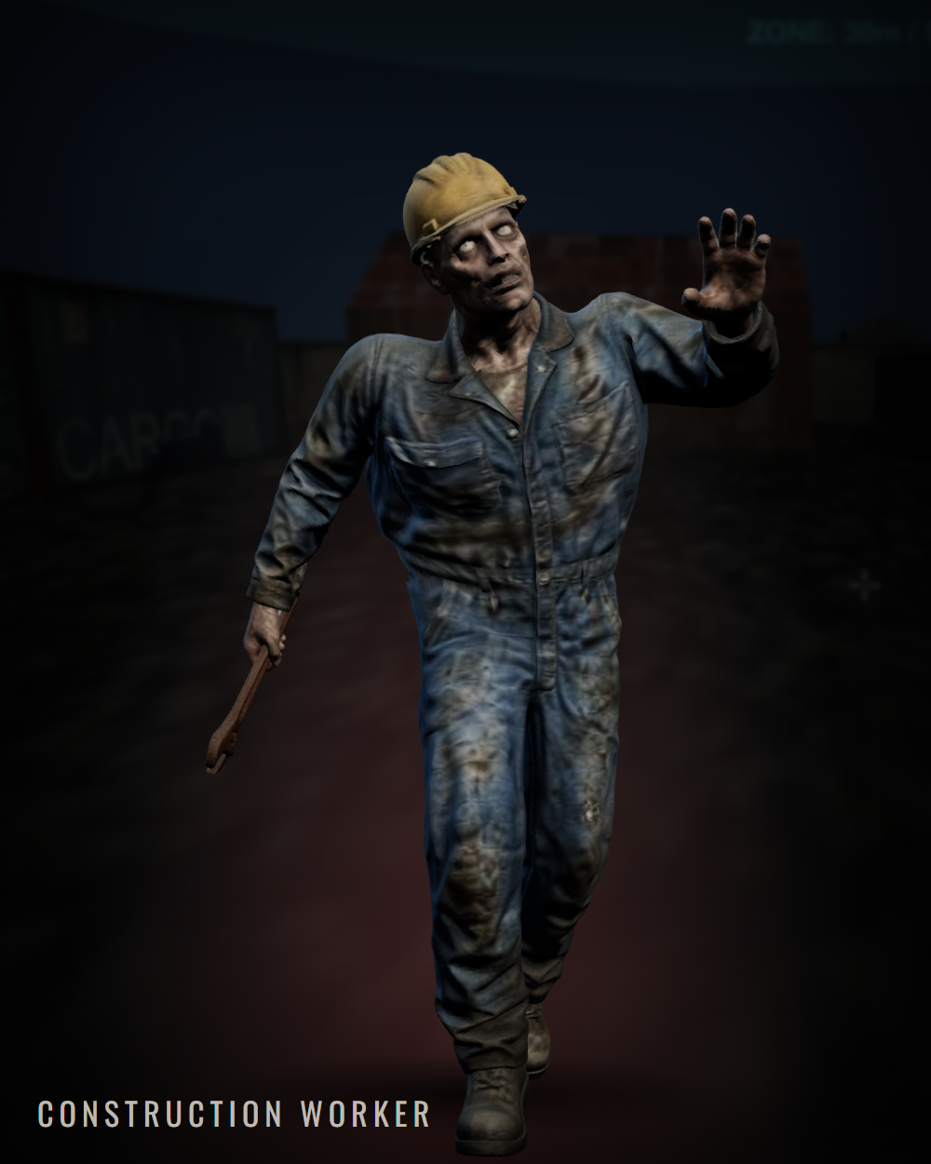 | 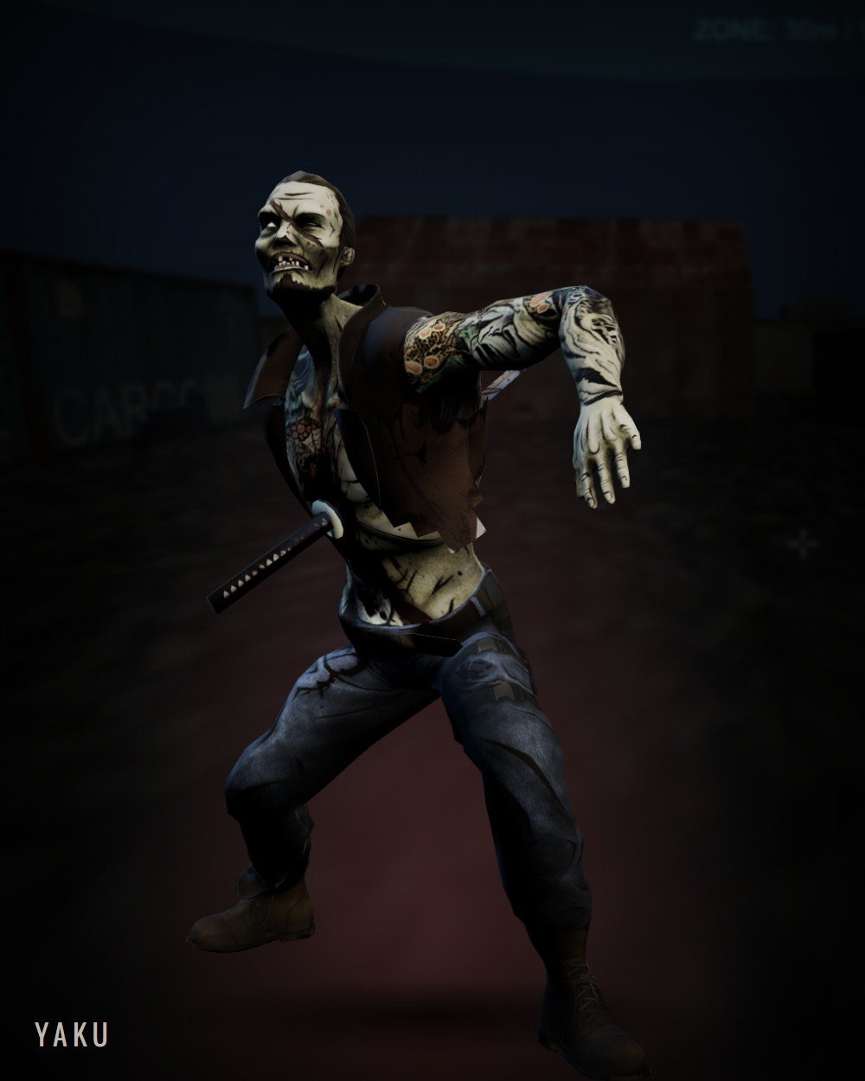
Left: the Construction Worker. Right: the Yaku mid-punch.
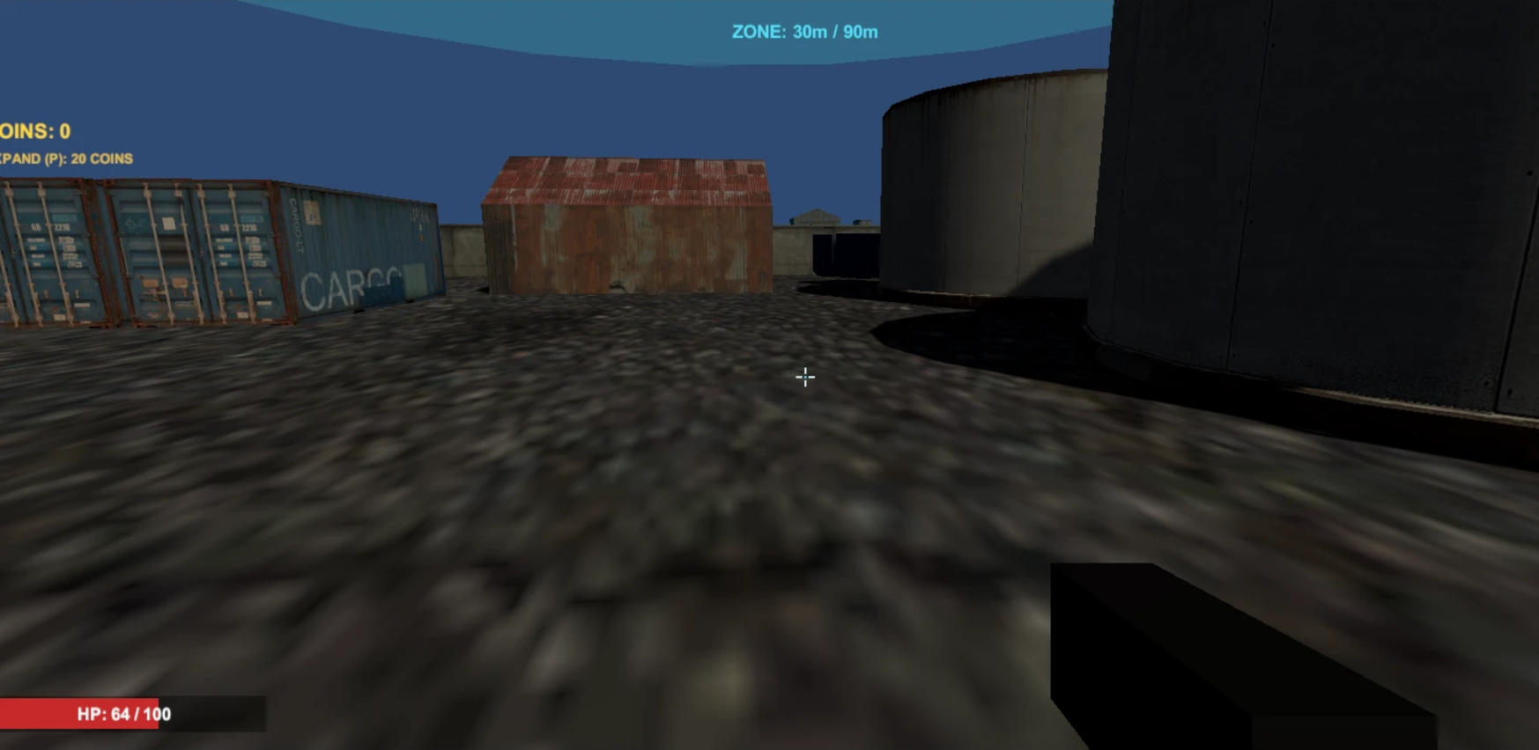
In-engine screenshot of the starting compound (current build).
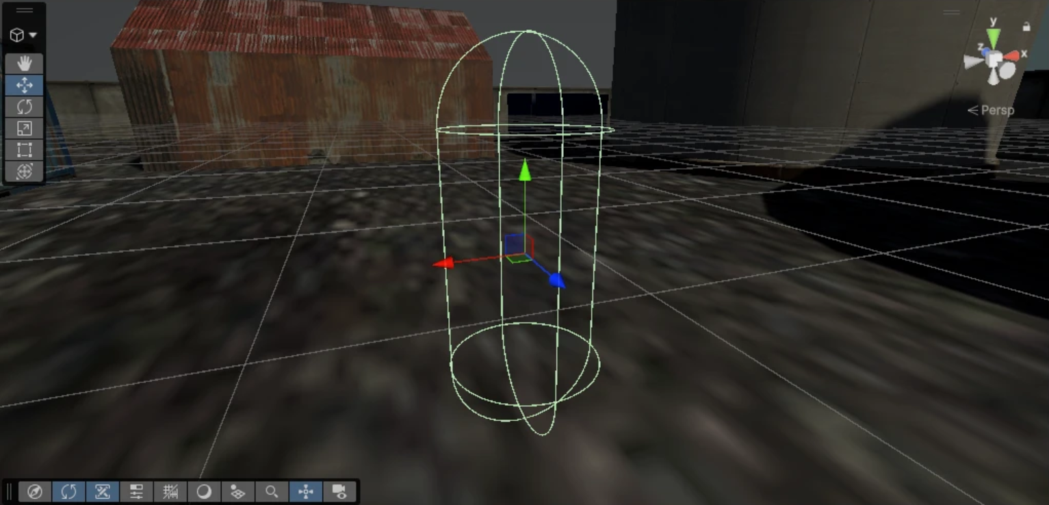
The starting compound in the Unity editor, with the player capsule at the spawn.

Game Mechanics

Core Game Play
The core game play in Zombie Rush is a loop of surviving a wave, collecting its rewards and spending them to make the next wave survivable. Everything the player does serves one of those three steps.
Fighting – Combat is about positioning under pressure. Zombies never arrive from one direction: they surface from five pads around the compound at the same moment and all head straight for the player. A player who stands still is surrounded within seconds. The containers, hangars and oil tanks inside the compound break the zombies' lines of approach and create choke points, and the zombie AI slides along walls rather than through them, so good use of cover buys real time. The pistol rewards accuracy at range, while the shotgun deletes anything that gets close but reloads slowly. Choosing when to reload, and when to switch weapons instead, is a constant decision.
Economy – Kills drop coins and, less often, ammunition. Between waves the player decides whether to spend coins on expanding the zone. A bigger zone gives more space to retreat into and reaches more cover, but it also means the zombies have further to come from and the player has more ground to watch.
The Boundary – The safe zone is a hard wall. The player's position is clamped to the zone's radius every frame, so the only way to get more room is to earn it. This keeps early waves tight and tense, and makes each expansion feel like real progress.

Game Flow
A typical run follows the same rhythm, wave after wave:
- Announcement – "WAVE N INCOMING" appears for 3 seconds and the player is healed back to 100 HP.
- Spawning – zombies rise from all five spawn points at once, in rounds 0.8 seconds apart, until the wave's total has spawned.
- Fighting – the wave continues until every zombie is dead. Each kill drops coins and sometimes ammunition.
- Clear – "WAVE N CLEARED" appears, followed by a 5-second breather to reposition and spend coins.
- Next wave – the wave number goes up and the loop repeats. If the player's health reaches zero at any point, "YOU DIED" is shown and the game restarts from wave 1 after 2.5 seconds.
The size and strength of each wave follow two simple formulas: zombies per wave = 5 + 2 × (wave − 1), and zombie strength multiplier = 1 + 0.15 × (wave − 1). The multiplier scales zombie health and damage, and scales movement speed up to a cap of 1.6×.
Wave | Zombies | Strength  multiplier | Worker HP /  hit damage | Yaku HP /  hit damage | Worker / Yaku  run speed (m/s)
1 | 5 | ×1.00 | 60 / 12 | – | 3.5 / –
2 | 7 | ×1.15 | 69 / 13.8 | 126.5 / 20.7 | 4.0 / 3.7
3 | 9 | ×1.30 | 78 / 15.6 | 143 / 23.4 | 4.5 / 4.2
5 | 13 | ×1.60 | 96 / 19.2 | 176 / 28.8 | 5.6 / 5.1
10 | 23 | ×2.35 | 141 / 28.2 | 258.5 / 42.3 | 5.6 / 5.1
From wave 5 onward the Construction Worker runs at 5.6 m/s, faster than the player's 5 m/s walk, so from that point the player must sprint to open distance. This is the intended difficulty curve: early waves teach the loop, later waves force movement.

Characters

The Survivor
The player character is an unnamed survivor seen only in first person. The survivor has no special abilities: 100 health points, a pistol and a shotgun. Health is restored to full at the start of every wave, so each wave is a fresh test rather than a slow drain. The survivor walks at 5 m/s, sprints at 8 m/s, crouches at 2.5 m/s and can jump about 1.2 metres, enough to clear low props.

Zombies
The tables below show how many hits it takes to kill each zombie at different waves. Pistol figures assume every shot hits. Shotgun figures run from all 8 pellets hitting at close range to 5 of 8 hitting at medium range. "–" means that zombie type does not spawn in that wave.

Construction Worker
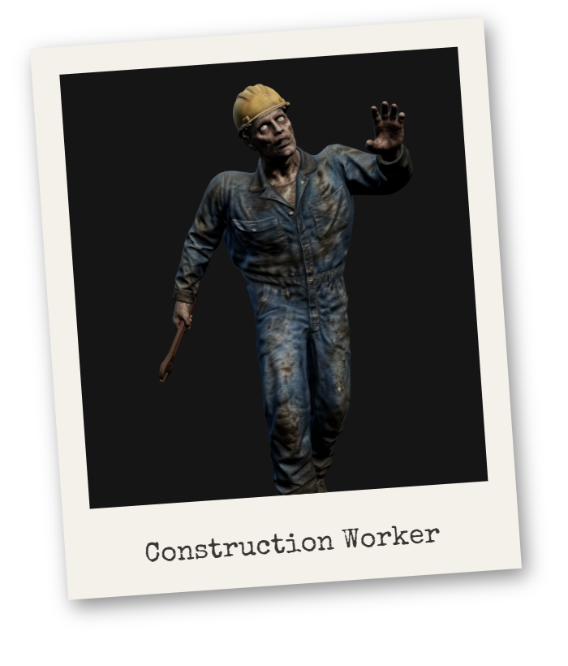 | The most common zombie: a dead site worker still in his overalls and hard hat, dragging a wrench. He is not fast at first, but there are many of him, he always comes straight for the player, and he gets stronger every wave. His punch deals 12 damage every 1.1 seconds at wave 1.
  Weapon | Wave 1 | Wave 3 | Wave 5 | Wave 10
  Pistol | 3 | 4 | 4 | 6
  Shotgun | 1-2 | 2 | 2-3 | 2-4
  Zombie health | 60 | 78 | 96 | 141

Yaku
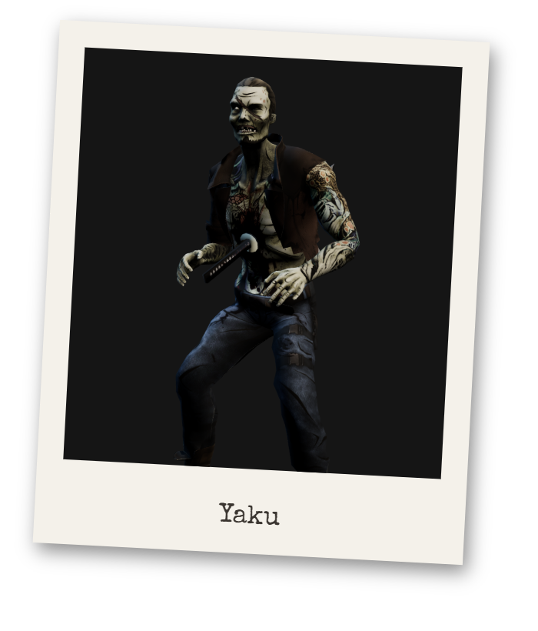 | A heavily tattooed gangster with a sword still stuck through his body. The Yaku first appears in wave 2 and is the tank of the horde: nearly twice the health of a worker and a harder punch. At distance he walks at 2 m/s; once within 12 metres he breaks into a run at 3.2 m/s, so he punishes players who let him close in.
  Weapon | Wave 1 | Wave 3 | Wave 5 | Wave 10
  Pistol | – | 6 | 8 | 11
  Shotgun | – | 2-4 | 3-4 | 4-6
  Zombie health | – | 143 | 176 | 258.5
Both zombie types share the same AI, health and collision setup; each type only swaps its model, animations and a stats asset. The base stats are:
Stat | Construction Worker | Yaku
Health | 60 | 110
Walk / run speed (m/s) | 2.2 / 3.5 (always runs) | 2.0 / 3.2 (runs within 12 m)
Attack damage | 12 | 18
Attack range | 1.6 m | 1.7 m
Attack cooldown | 1.1 s | 1.4 s
Sight range | 25 m | 40 m
First wave | 1 | 2
Spawn weight | 3 | 2 (≈40% of spawns from wave 2)
Planned zombie types (proposals):
- Runner – low health, very fast, appears in small numbers from wave 4 to break up the rhythm of the horde.
- Brute – very high health and a slow, heavy attack that knocks the player back; a mini-boss every fifth wave.
- Spitter – keeps its distance and throws acid, forcing the player out of cover.

Game Play Elements

Coins
Coins are the only currency. Every zombie killed drops 5 to 15 coins. These are the values currently used for testing; the intended release values are a 40% chance of 1 to 5 coins per kill, so that expansions become a meaningful choice. The coin total and the cost of the next expansion are shown separately on the HUD.

Ammunition Drops
Each kill has a 25% chance to drop 4 to 10 rounds, which are added to the reserve of every weapon the player carries, up to each weapon's maximum reserve.

Health
The player has 100 health points and there are no health pickups. Instead, health is restored to full when each new wave is announced. Taking damage flashes the screen red.

Safe Zone
The zone is shown as a translucent cyan cylinder around the compound. It starts at a 30 metre radius and each expansion adds 15 metres, up to 90 metres, for 20 coins each. Expansion is currently triggered with the P key; a physical purchase terminal in the compound is planned.

Spawn Points
Five spawn pads around the compound pulse red-orange so the player can read where the next zombies will surface. Zombies start 2.2 metres below ground and rise to the surface over 1 second, during which they cannot move or attack.

Weapons
The pistol is the reliable all-rounder: accurate at any range, quick to fire and quick to reload, but it needs several hits per zombie. The shotgun fires eight pellets in a spread and can kill an early-wave zombie in one shot at close range, but it has only six shells in the magazine, a short effective range and a slow reload.

Weapon Properties

Firearms
Weapon | Pistol | Shotgun
Slot key | 1 | 2
Damage per shot | 25 | 9 per pellet × 8 (72 max)
Shots per second | 6 | 1.1
1 shot every … seconds | 0.17 | 0.91
Effective range | 100 m | 18 m
Spread | None (hitscan) | ±6° cone
Magazine | 12 | 6
Maximum reserve | 60 | 24
Reload time | 1.4 s | 2.2 s
Possible to move while shooting | Yes | Yes
Auto-reload on empty | Yes | Yes

Game Physics and Statistics
Movement – The survivor uses a character controller. Walking speed is 5 m/s. Holding Left Shift while moving forward sprints at 8 m/s; sprinting is not possible while crouched or moving backwards. Crouching lowers the body from 1.8 to 1.0 metres and the camera from 1.6 to 0.9 metres, and slows movement to 2.5 m/s. A jump reaches about 1.2 metres under a gravity of 20 m/s². Mouse look is clamped to 85 degrees up and down. The zone boundary is applied after movement every frame, so the player slides along the edge of the zone rather than passing through it.
Combat – Both guns are hitscan: each shot or pellet is a ray cast from the centre of the camera, so what is under the crosshair is what gets hit. Zombies currently take the same damage wherever they are hit; head-shot bonus damage is planned. A zombie that is hit plays a hit-reaction animation, and a zombie that dies plays its death animation or collapses to the ground, bleeds, drops its rewards and is removed after 4 seconds. Zombie strength scales with the wave as described under Game Flow.

Artificial Intelligence
The zombie AI is deliberately lightweight so that dozens of zombies can run on a phone. It does not use a navigation mesh. Instead, every zombie runs the same short set of rules each frame:
- Sight – if the player is further away than the zombie's sight range, it stands idle. Within range, it always knows where the player is.
- Attack – within attack range the zombie stops, turns to face the player and punches on a cooldown, dealing its damage multiplied by the wave multiplier.
- Chase – otherwise it moves toward the player, walking if it is further than its run distance and running once closer.
- Avoidance – a sphere is cast 1.6 metres ahead of the zombie. If it hits a wall or prop, the zombie slides along that surface, committing to the new direction for 0.35 seconds so it does not jitter. Other zombies and the player are ignored by this check.
- Unsticking – if a zombie has moved less than 0.15 metres in half a second, it walks in a random direction for 1.2 seconds to escape the corner it is stuck in.
The avoidance check runs about ten times per second per zombie, with each zombie offset slightly, to spread the physics cost across frames. A navigation mesh may be added for the larger Zone B, where long walls make simple wall-sliding less reliable.

Player Controls
Action | PC (keyboard & mouse) | Android (touch – planned)
Move | W A S D | Virtual stick, left side
Look | Mouse | Drag on right half of screen
Fire | Left mouse button (hold) | Fire button
Reload | R | Reload button
Switch weapon | 1 / 2 | Tap weapon icon
Sprint | Left Shift | Push stick fully forward
Crouch | Left Ctrl or C | Crouch button
Jump | Space | Jump button
Expand zone | P | Expand button
Pause | Esc | Pause button
Restart after death | R (or wait 2.5 s) | Automatic

Multiplayer
Online co-op is planned for 2 to 4 players defending the same compound. This section is a proposal.
- Authority – one player hosts the match. The host decides waves, zombie spawns and deaths, coin drops and the zone radius, and the other players receive those results, so every player sees the same game.
- Scaling – zombies per wave and zombie health scale with the number of players, so a wave is not trivial with four guns.
- Coins and the zone – each player earns their own coins, but any player can pay to expand the shared zone.
- Downed, not dead – a player at zero health is downed and can be revived by a teammate within a short time; the run only ends when every player is down.
- Technology – Unity Netcode for GameObjects with Unity Relay and Lobby, which works on both PC and Android without dedicated servers. Photon Fusion is the alternative if hosting costs or latency require it.

Interface

Flowcharts
The following charts show the core game loop, the zombie AI, the flow between screens and the planned options screen. On the screen flow chart, solid boxes are implemented and dashed boxes are planned.
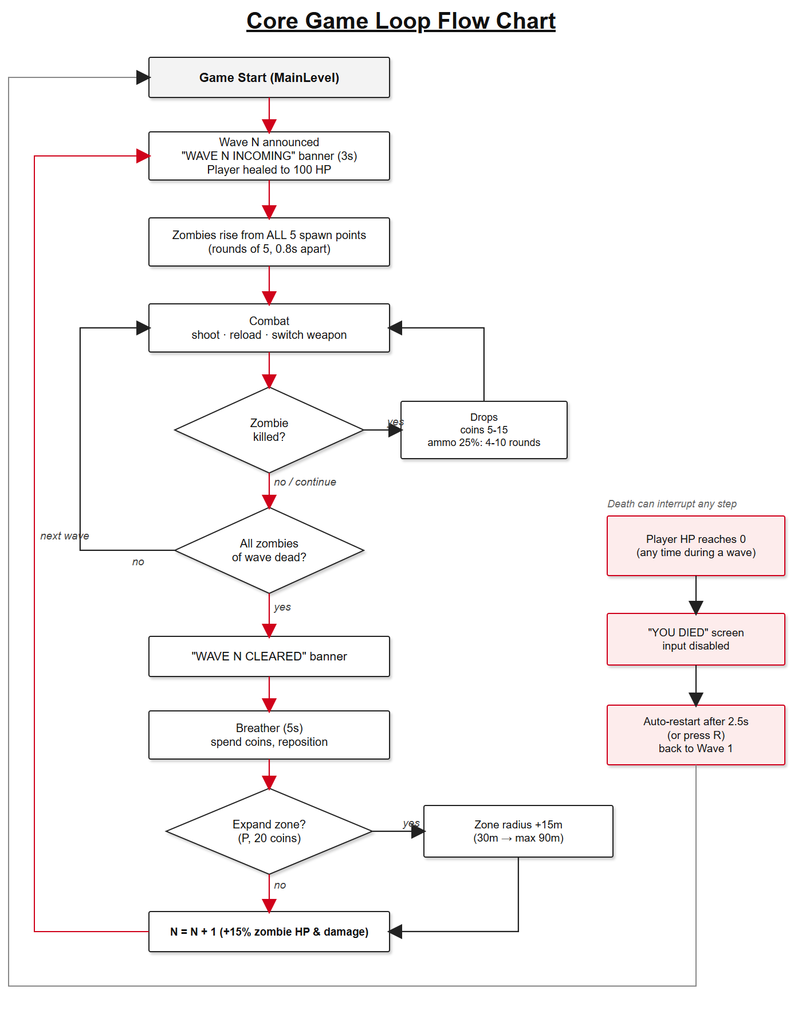
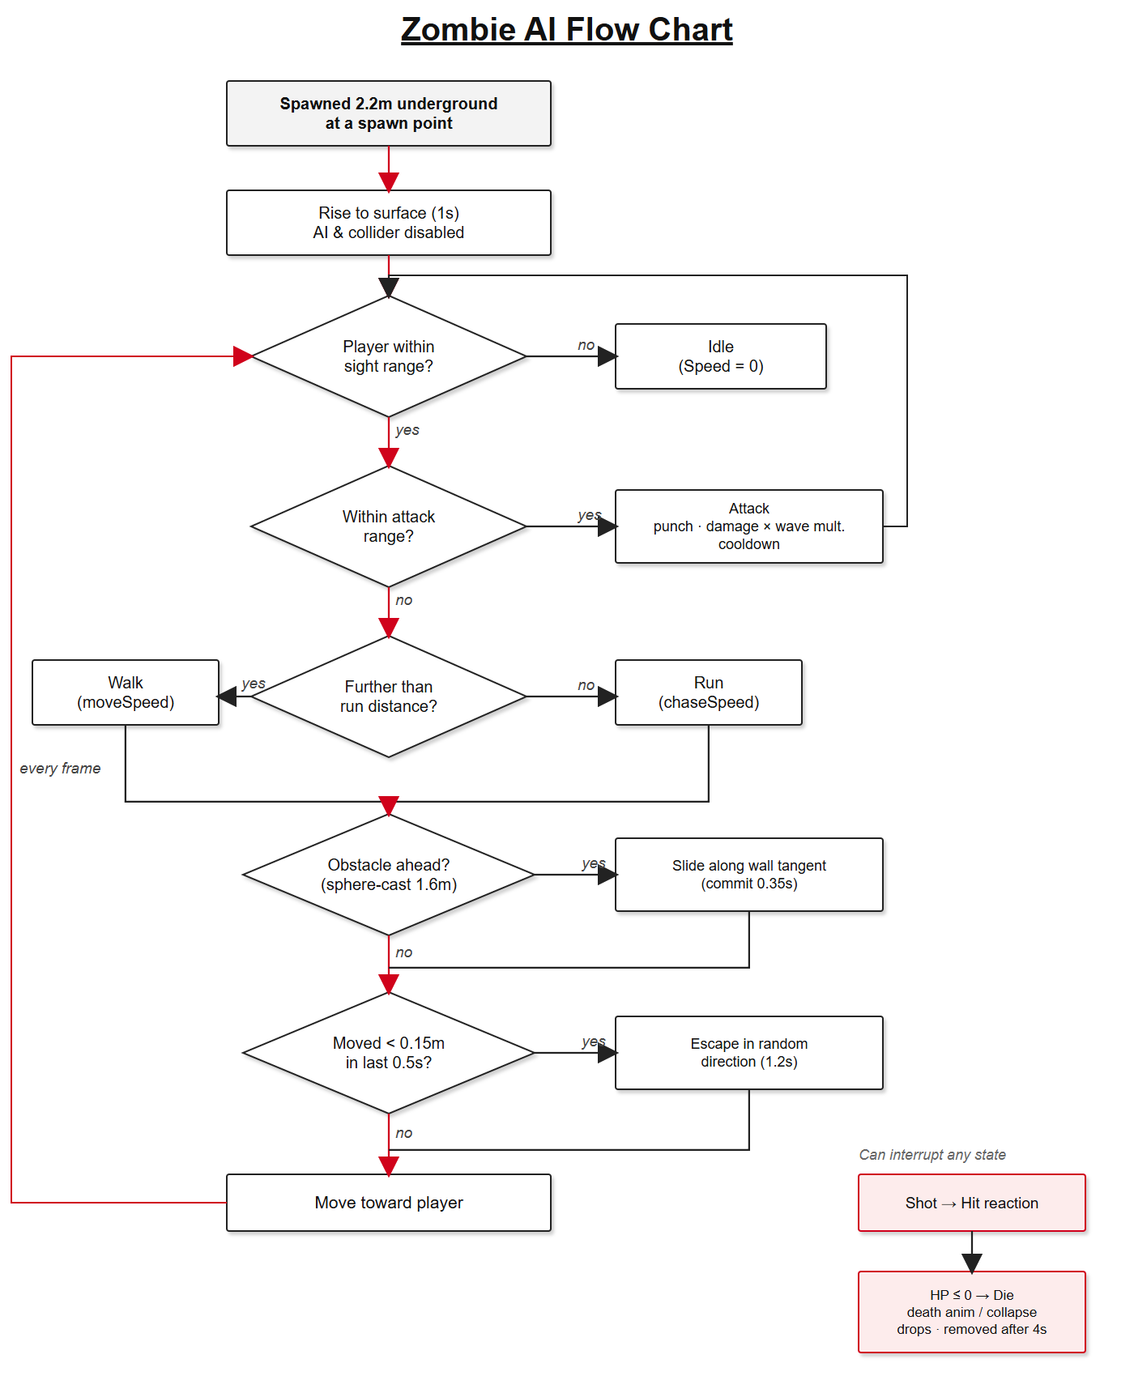
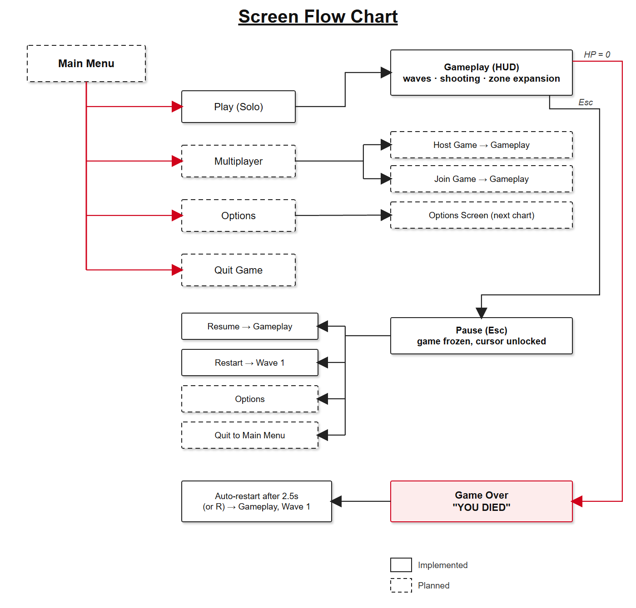
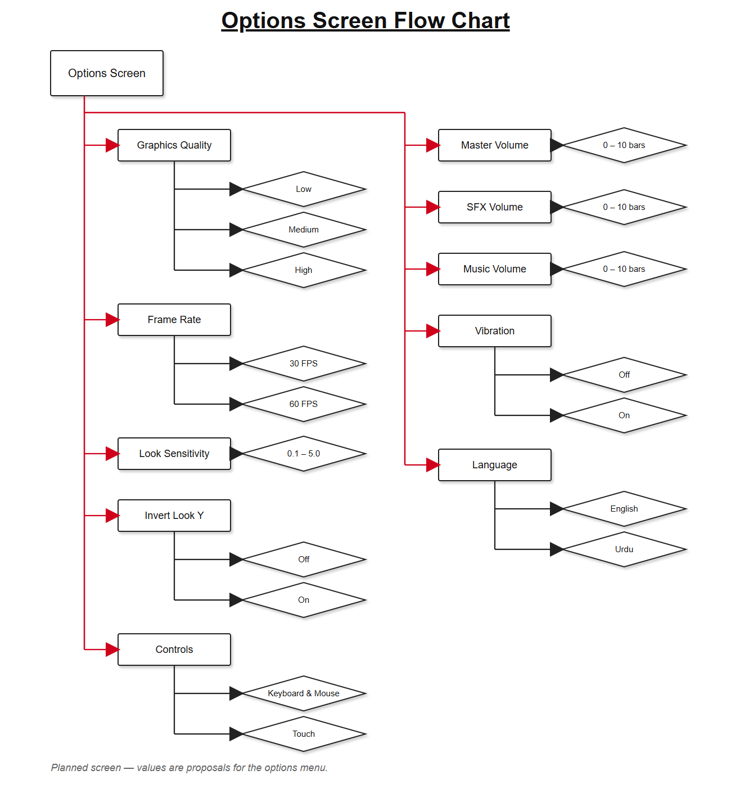

Functional Requirements
- Main Menu (planned)
The main menu uses a simple highlighted selection that works with the mouse, keyboard or touch.
1:1 – Play
Starts a solo game at wave 1 in the starting compound.
1:2 – Multiplayer
Opens Host Game and Join Game for online co-op.
1:3 – Options
Opens the options screen: graphics quality, frame rate, look sensitivity, invert look, control scheme, master, sound effects and music volume, vibration and language.
1:4 – Quit
Closes the game on PC; on Android it returns to the home screen.
- In Game HUD (implemented)
2:1 – Zone
Top centre, cyan: current radius and maximum, for example "ZONE: 45m / 90m", or "(FULL)" at the maximum.
2:2 – Coins
Left, gold: the coin total, "COINS: 35".
2:3 – Expansion cost
Below the coins: "EXPAND (P): 20 COINS". Hidden once the zone is full.
2:4 – Crosshair
A thin cross with a centre dot, always in the middle of the screen.
2:5 – Health
Bottom left: a red bar that eases down smoothly when hit, with "HP: 64 / 100" over it.
2:6 – Weapon and ammo
Bottom right: weapon name, a large magazine count, then the magazine size and reserve, "/ 12 (48)". Shows "..." while reloading.
2:7 – Wave banner
Top centre: "WAVE N INCOMING" for the 3-second announcement and "WAVE N CLEARED" for 2 seconds after a wave.
2:8 – Damage flash
A full-screen red flash that fades out whenever the player loses health.
- Pause and Game Over
Pressing Esc freezes the game and frees the cursor; the pause menu with Resume, Restart, Options and Quit to Menu is planned. When the player's health reaches zero, "YOU DIED" is shown over a dark red screen and the game restarts from wave 1 after 2.5 seconds, or immediately if R is pressed.

Mock Up Screens
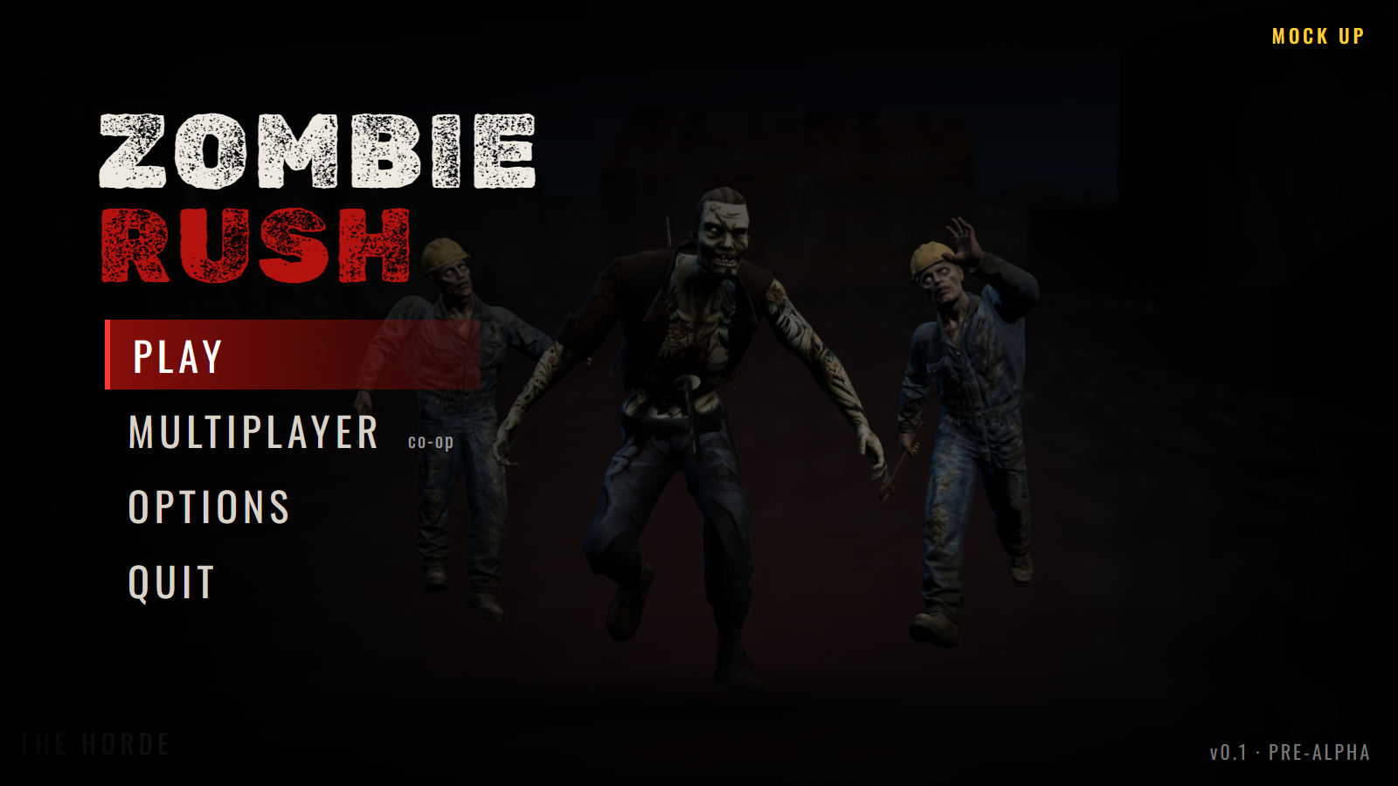
Main menu (planned).
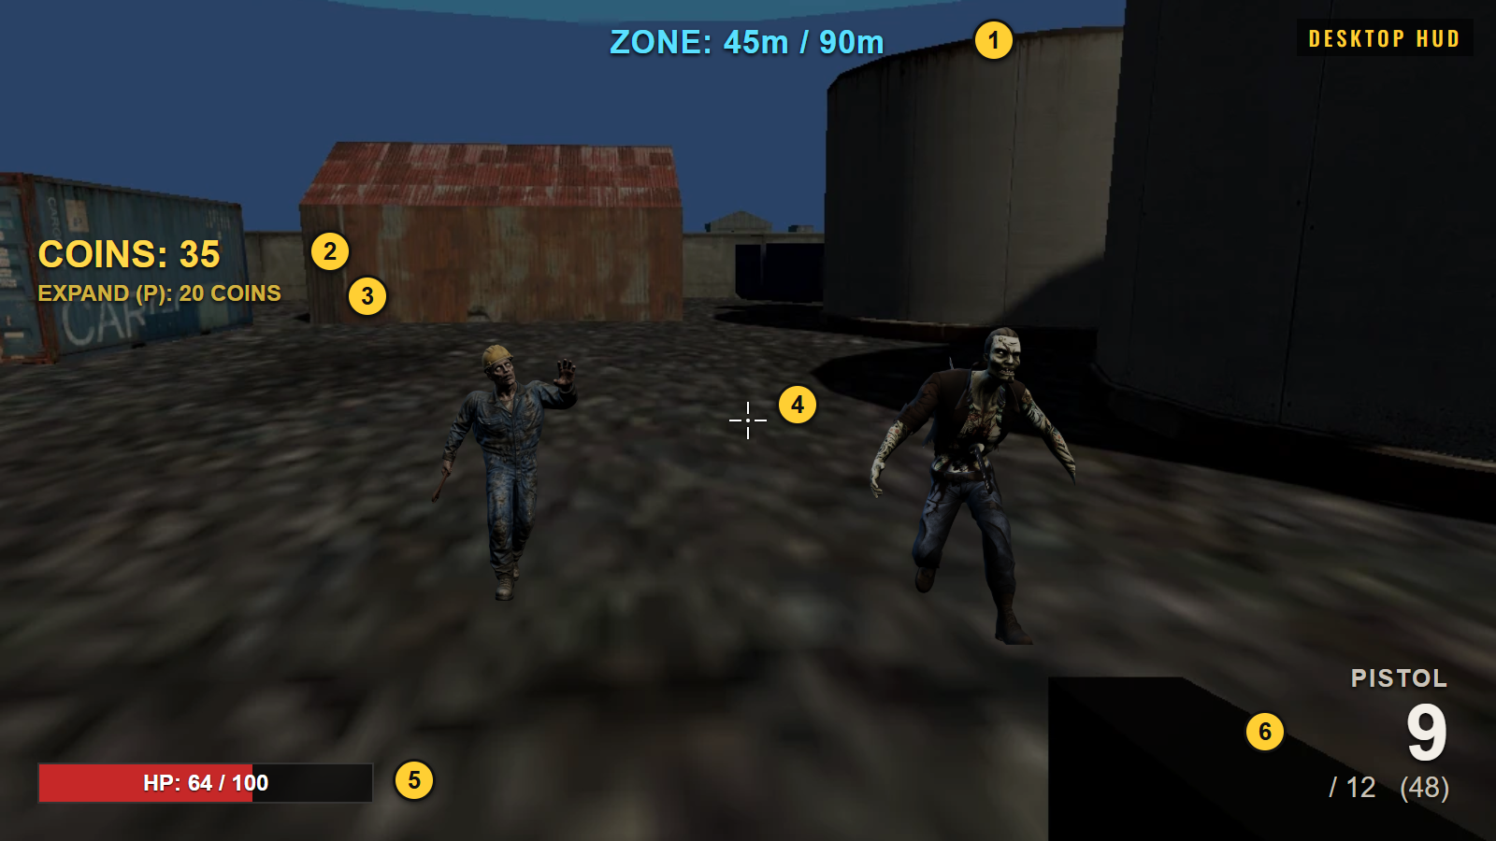
Desktop HUD. Numbers match 2:1 to 2:6 above.
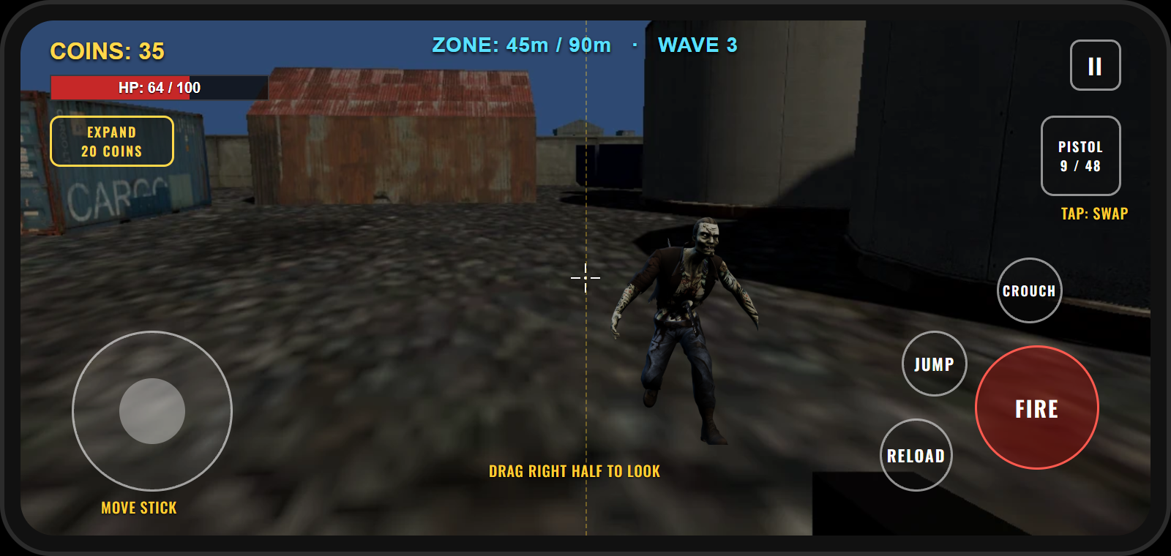
Mobile HUD with touch controls (planned).
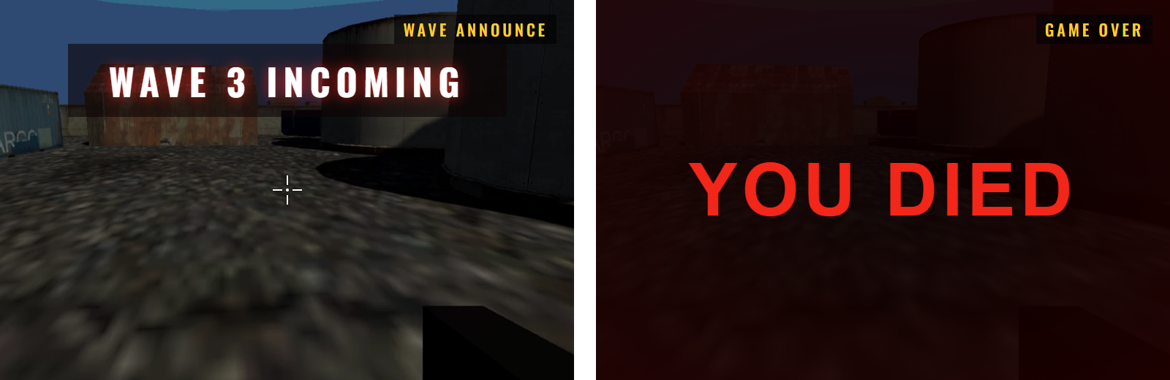
Wave announcement and Game Over screens (implemented).
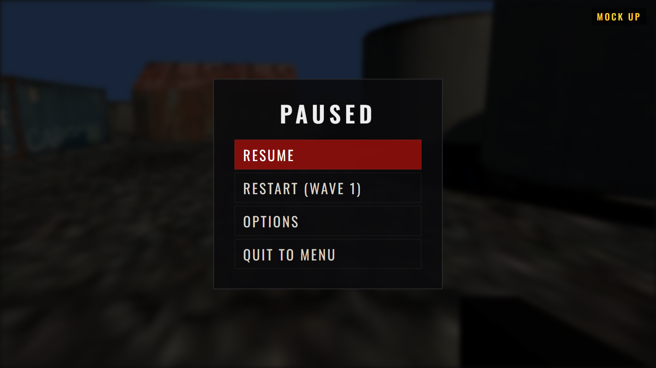 | 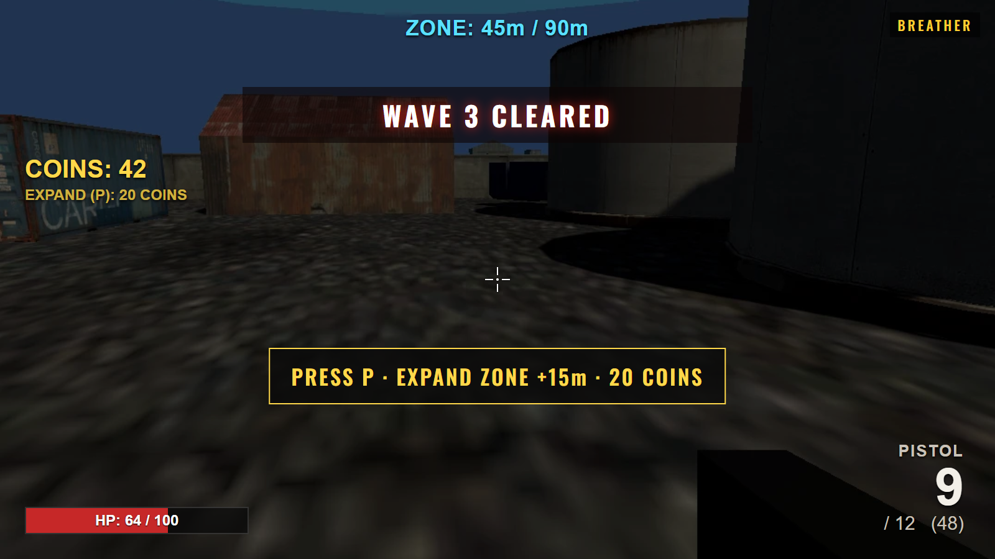
Left: pause menu (planned). Right: breather after a cleared wave, with the expansion prompt.

Art and Video

Overall Goals
The art direction of Zombie Rush is grounded and gritty: an industrial district at dusk, with rusted corrugated hangars, faded shipping containers, stained concrete and oil tanks under a dark blue sky. The palette is kept desaturated so that the few strong colours the game uses always carry meaning.
That colour language is the most important visual rule. Cyan means safety: the zone wall and the zone readout are cyan. Red means danger: spawn pads glow red-orange, blood is dark red, and the screen flashes red when the player is hurt. Gold means reward: coins and the expansion prompt are gold. A player should be able to read the state of the game from colour alone, even on a small phone screen in bright light.
The zombies are realistic rather than cartoonish, with clear silhouettes that read at a distance: the hard hat and overalls of the worker, the tattoos and sword of the Yaku. Every visual choice is also checked against the mobile budget, so real-time lighting is kept simple and effects are pooled rather than created on the fly.

2D Art
- HUD elements: health bar, crosshair, weapon and ammo readout, coin counter, wave banners
- Touch control buttons and virtual stick
- Menu backgrounds and the Zombie Rush logo
- Weapon and zombie icons
- Environment textures (from the Industrial Set, converted to URP)
- Google Play store icon, feature graphic and screenshots
- Steam or store page art for the PC release

3D Art & Animation
- Environment: hangars, containers, oil tanks, pipes, generators, fences and props from the Industrial Set v2.0
- Zombie models: Construction Worker and Yaku (Meshy AI)
- Zombie animations (Mixamo): Idle, Walking, Run, Punching, Reaction Hit, Dying
- First-person weapon models: pistol and shotgun (currently simple placeholder shapes)
- First-person arms with fire and reload animations (planned)

Cinematics & VFX
- Blood bursts on every hit and on death, drawn from a pool of reusable particle systems
- Pulsing glow on spawn pads
- Zombies rising out of the ground when they spawn
- Death animation or collapse when a zombie is killed
- Full-screen damage flash and the fading wave banners
- A short gameplay trailer for the store pages (planned)

Sound and Music

Overall Goals
The current build has no audio yet; this chapter sets out what the audio needs to do. Sound in a horde shooter is information as much as atmosphere. The player must be able to hear where zombies are coming from, that a wave is about to start, and that their magazine is about to run dry, without looking at the HUD.
Music should build with the wave: quiet and tense during the breather, rising as the wave is announced, and at full intensity while the zombies are up. On mobile, music is streamed and effects are compressed, so the audio stays small in memory and in download size.

Sound Effects & Music
- Weapons: distinct pistol and shotgun shots, dry-fire click, reload sequences, shell drop
- Zombies: groans and snarls with several variations per type, footsteps, punches, hit reactions, death
- Spawning: an earth-cracking rumble from each spawn pad as zombies rise, audible in 3D so the player can locate it
- Player: footsteps on concrete and gravel, breathing when low on health, hurt sounds
- Economy and UI: coin pickup, zone expansion hum, wave incoming and wave cleared stingers
- Music: layered tracks that add intensity as each wave progresses

Story

Story Overview
Zombie Rush is an arcade survival game, so story is kept to a premise that explains the setting. The premise below is a proposal.
An outbreak has swept through an industrial district on the edge of a city. The workers were the first to fall, still in their overalls and hard hats, and the district was sealed off and left to rot. The survivor is trapped inside the quarantine with a pistol, a shotgun and a small fenced yard of containers and hangars that can still be defended.
The dead do not come through the gates. They come up through the ground, from the service tunnels and flooded basements beneath the yard, so there is never a safe side to stand on. Among them are stranger things: the Yaku, a tattooed gangster who died with a sword through his body and still has not stopped fighting.
The story is delivered through the environment and short text between waves rather than cutscenes, which keeps the game fast and the download small.

Endings & Progression
There is no final ending. The game is endless, and a run is measured by the highest wave reached. When the survivor dies, the run ends and the game restarts at wave 1 in the starting compound.
A best-wave record and unlockable cosmetic items are planned as the long-term goals that bring players back. Later, reaching Zone B could become a milestone within a run, with its own objective, before the waves resume at a higher difficulty.
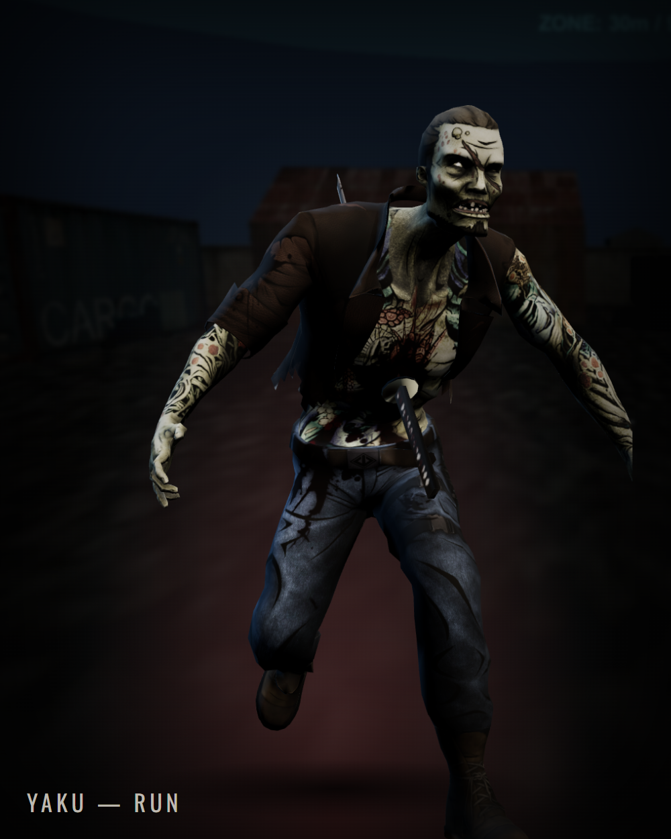
The Yaku breaking into a run once it is within 12 metres.

Level Overview
The level is one continuous industrial map made of two fenced areas joined by a road. Only Zone A, the starting compound, is currently reachable in play. The map below is drawn from the positions of the objects in the Unity scene.
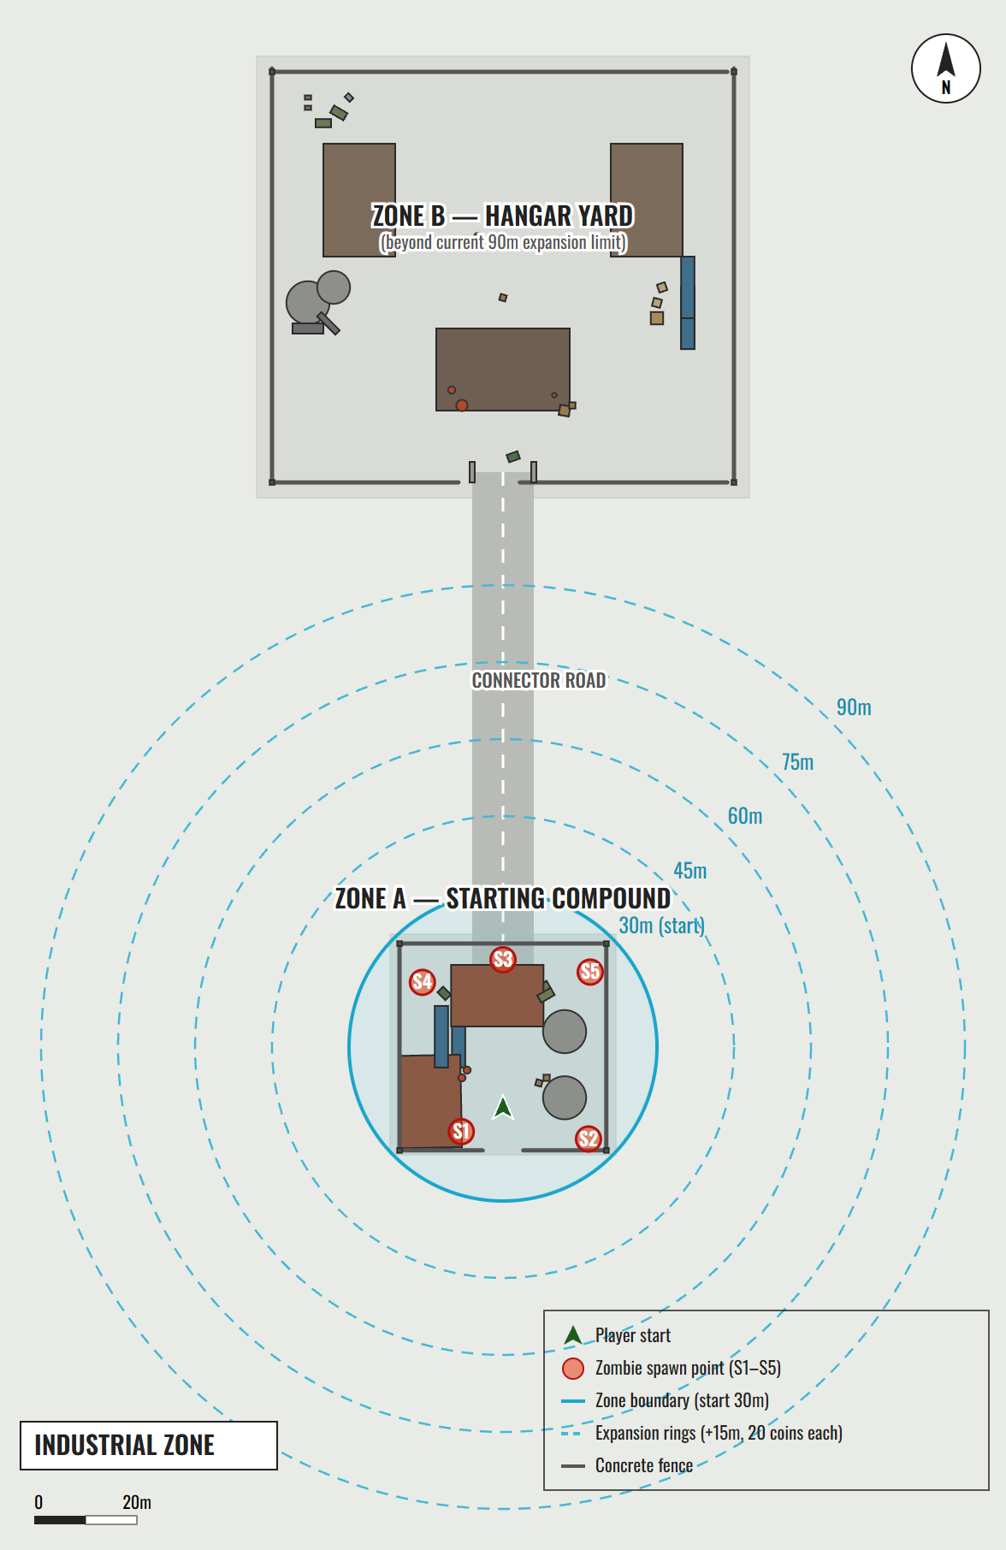

Location Overviews

Zone A – Starting Compound
A fenced yard of roughly 44 by 43 metres where every run begins. Two corrugated-iron hangars stand on the west and north sides, with a stack of shipping containers between them. Two large oil tanks fill the east side, and barrels, wooden crates, generators and a dumpster are scattered through the yard. The player starts in the south-centre, facing north. The five spawn pads sit just inside the fences at the corners and the north, so zombies surface around the player on every side.

Connector Road
A straight service road runs about 100 metres north from Zone A to Zone B. It is open ground with no cover, which will make it the most dangerous place on the map once it is inside the zone.

Zone B – Hangar Yard
A larger fenced yard of 96 by 86 metres. A wide hangar faces the road entrance, which is narrowed by a pair of road blocks, with two more hangars along the west and east sides. The west side holds oil tanks and pipework, the east side containers and pallets of sacks, and the north-west corner generators and electrical boxes. Barrels and crates are scattered in front of the main hangar.
Design note: the zone is centred on Zone A and its maximum radius is 90 metres, which ends just short of Zone B. Before Zone B can be used, either the maximum radius needs to be raised to about 200 metres, or the zone needs a second centre that moves to Zone B once Zone A is fully expanded.

Zone Expansion
Each expansion adds 15 metres to the radius of the safe zone and costs 20 coins.
Stage | Radius | Total coins spent | Playable area
Start | 30 m | 0 | 2,827 m²
1 | 45 m | 20 | 6,362 m²
2 | 60 m | 40 | 11,310 m²
3 | 75 m | 60 | 17,671 m²
4 (maximum) | 90 m | 80 | 25,447 m²
Spawn points:
Spawn point | Position (x, z) | Distance from zone centre
S1 | 491.9, 483.5 | 18.4 m
S2 | 516.7, 482.1 | 24.5 m
S3 | 500.0, 517.0 | 17.0 m
S4 | 484.3, 512.6 | 20.1 m
S5 | 517.0, 514.6 | 22.4 m
All five spawn points are inside the starting 30 metre zone and they do not move as the zone grows. A proposed improvement is to give each expansion ring its own set of spawn points, so zombies keep arriving from the edge of whatever area the player controls.

Market Analysis

Target Market
Zombie Rush targets two audiences with one game. On PC, it is aimed at players who enjoy short, replayable co-op shooters and horde modes. On Android, it is aimed at the large audience for zombie shooters on phones, who want a game that can be played in a few minutes, with controls that work on a touch screen.
The core age range is 13 to 30. The violence is fantasy horror against zombies rather than people, which suits a Teen-style rating on the store. The simple rules and short runs suit mobile play, while the rising difficulty, the zone economy and co-op give PC players a reason to master it.
A proposed business model is a low-price premium release on PC, and a free release on Google Play supported by optional rewarded ads and cosmetic purchases, with nothing sold that makes the player stronger.

Top Performers
The zombie wave-survival format has proven itself many times over. The Zombies mode of the Call of Duty series built a lasting audience on exactly this loop of surviving rounds, earning points from kills and spending them to open up the map. Killing Floor 2 showed how well a co-op wave shooter with an economy between waves works on PC. On mobile, Dead Trigger 2 and Into the Dead 2 showed that zombie shooting with simplified controls can reach a very large audience.
Zombie Rush takes the round-based structure and map-opening economy of these games and fits it into a format small and quick enough for a phone, without losing the tension that makes the genre work.

Feature Comparison
Feature | Zombie Rush | Call of Duty Zombies | Killing Floor 2
Wave-based survival | Yes | Yes | Yes
Currency earned from kills | Yes (coins) | Yes (points) | Yes (dosh)
Currency opens more of the map | Yes (zone radius) | Yes (doors and barriers) | No
Weapon purchases | Planned | Yes | Yes
Online co-op | Planned | Yes | Yes
Built for phones as well as PC | Yes | No | No
The main difference is the expanding safe zone. Instead of opening doors one by one, Zombie Rush grows the whole playable area outward in rings, which is easy to understand at a glance and works on a small screen.

References
- Unity 6 Manual and Universal Render Pipeline documentation
Url: https://docs.unity3d.com/
- RPG/FPS Game Assets for PC/Mobile – Industrial Set v2.0 (Unity Asset Store) – environment art
- Meshy AI – zombie character models
Url: https://www.meshy.ai/
- Mixamo – zombie character animations
Url: https://www.mixamo.com/
- Google Play Console Help – app size and Play Asset Delivery
Url: https://support.google.com/googleplay/android-developer/
- Unity Netcode for GameObjects documentation
Url: https://docs-multiplayer.unity3d.com/
- three.js – used to render the character images in this document
Url: https://threejs.org/
- Oliver James Cooke, "Silent Hill 2 Design Document" – layout reference for this document
- Tim Ryan, "The Anatomy of a Design Document"

